**Q: 13**

**Title:**

L1 - Creating layout from given Design

**Problem Statement:**

Create the following layout , using FLEX (submission which use GRID will not be accepted at all) .

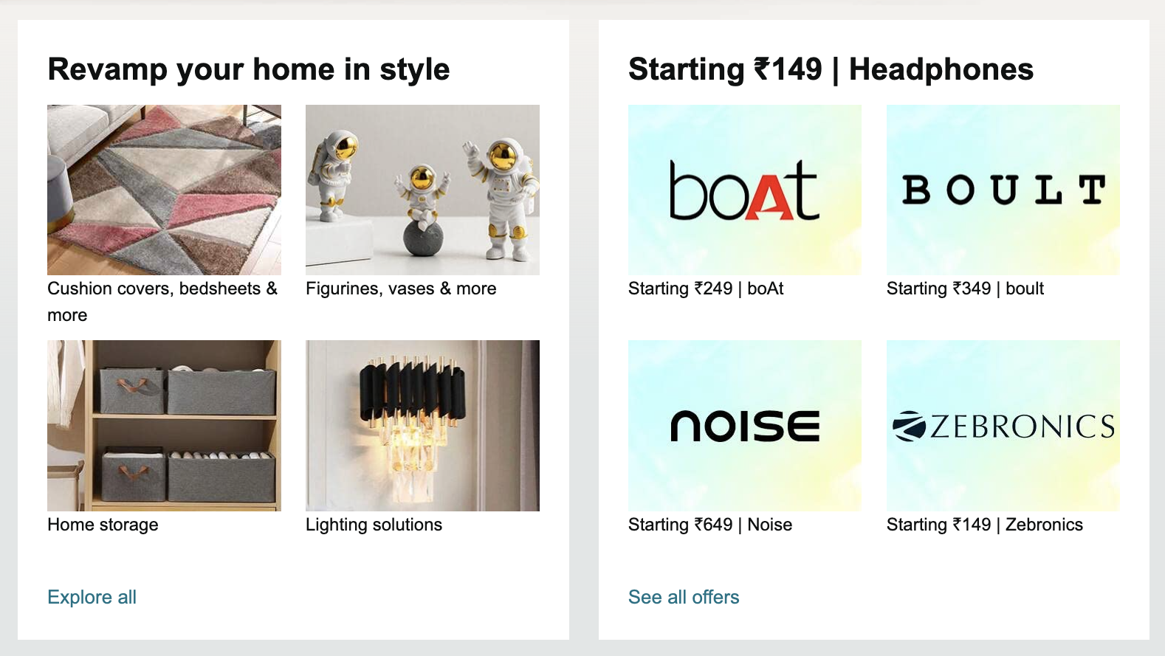

**Submission Guidelines:**

* Submit the link to your Masai Git repository containing the HTML and CSS files.